CS148 Database Design

Hari Luitel

Final Project

FIFA SOCCER

Version <1.3>

Table Of Contents

Time Log 3

Introduction 4

Purpose 4

Definitions, acronyms, and abbreviations 4

Overall Description 4

Story Board 5

Data Dictionary 6

ER- Diagram 7

Specific requirements 9

# Introduction

### Purpose

The purpose of this project is to create something that is related to soccer and apply the knowledge we learned in class to create databases and ways of displaying information

The purpose of this document is to describe the requirement specification for the web site FIFA Soccer

The intended audience for this document is clients who wanted to create this website and developers who worked in this project.

### Definitions, acronyms, and abbreviations

FIFA - Fédération Internationale de Football Association

Ronaldo – Soccer Player, plays for Portugal and Juventus

Messi - Soccer Player, plays for Barcelona and Argentina

Ranking/Rating– number given to player by FIFA based on their ability

CB – Center Back

LB- Left Back

RB – Right Back

CB – Center Back

CM – Central Midfielder

LW- Left Winger

RW – Right Winger

ST – Striker

PhpMyAdmin – interface to database

Sql – Structured Query Language – used to manage database

Primary Key – unique value that identities each row of the a table

Foreign Key – value that connects two table

Validation – Used for safety measure to validate the user input/query

Sanitation – used for safety measure to Sanitize values

HTML – Hypertext Markup Language

PHP – Hypertext Preprocessor

ER Diagram – a diagram to represent the data you want to save with your system

W3 Validation – refers to both Html and CSS validation tool provided by the W3c.org. the html validator is located at:

<http://validator.w3.org/>

with the CSS validator located at:

<http://jigsaw.w3.org/css-validator/>

# Overall Description

FIFA Soccer allows you to create account, login, earn points, build players and play the game. Once you login in, every 24 hours, you will learn 100 points. Using those points, you can create a player card. It costs 1000 points. Once you have players in your team, you can play the Game. If you win, you get 50 points and if you lose, you lose 50 points.

Home Page – Displays Two of the Greatest Players Ronaldo and Messi

Squad Builder – Page That Allows you to create Player

Players Catalog – Page to search global players or players in your team

Player Pack – This is where you play the Game. Select a Player from your team, and play the game.

# Story Board

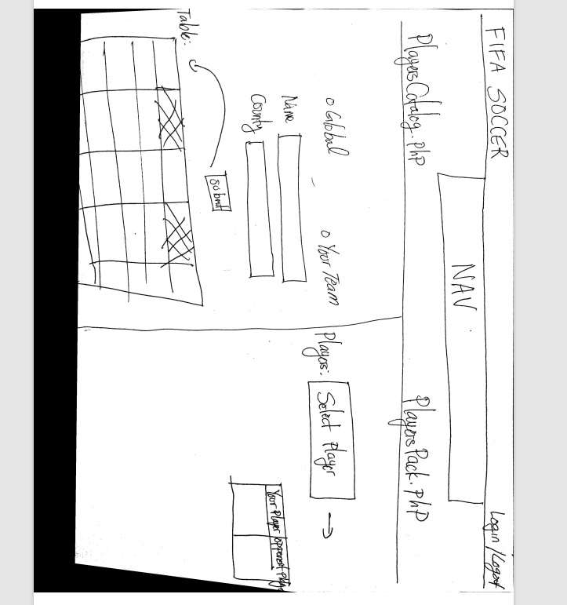

# Data Dictionary

Paste your Data Dictionary here. The final version is easy to get by exporting to the screen in phpMyadmin

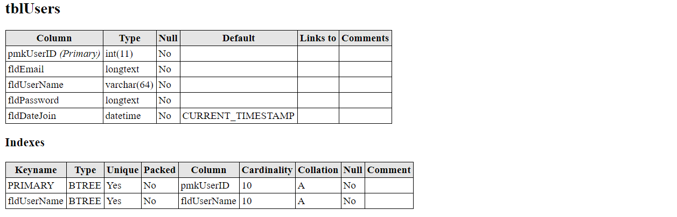

# ER- Diagram

# Schema

Paste your schema here. The final version is easy to get by exporting to the screen in phpMyadmin

# Specific requirements

1. *You fill out* – This is where you would put the exact detail of what you want for the project. For example:
2. *Title for main page*: FIFA Soccer
3. *Meta Description*:  *Soccer, Fifa, Ronaldo, Messi, Points, Fifa Rating*
4. *Meta Character set*: UTF - 8
5. *Logo*: *FIFA Soccer*
6. *Main page photo*: A picture containing person, person, posing

   Description automatically generated
7. CSS – Custom.CSS, Mobile.CSS, Tablet.CSS
8. Database Connection – Database Reader, Database Writer
9. Web Pages
10. **Header**

FIFA Soccer Logo

Display Username/Logout Functionality

1. **Nav**

Horizontal Bar Nav – Home | Squad Builder | Players Catalog | Players Pack

1. **Home**

Include Ronaldo Messi Photos

Stats about Messi and Ronaldo

1. **Squad Builder**

Forms to create Player

-Player Name, Rating, Position, and Attributes(Pace, Passing, Shooting, Strength, Heading) V.

1. **Players Catalog**

Display Global Players/Your Team Players

Global Players – FifaPlayers.csv

Your Players – tblUsersPlayers

1. **Players Pack**

Display Players in User Team

Randomly Generate Global Players

Decide Win/Lose based on the Rating of User Player and Global Player(i.e Computer Generate Player)

Supporting Pages/Files

Index.php

* Allows User to Login in to the website

CreateAccount.php

Used to create account